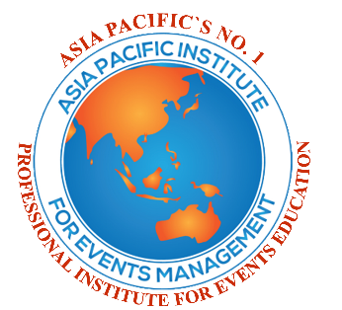

THE APIEM

INSTITUTIONAL MEMBER PARTNERSHIP

AND VENUE INFORMATION FORM

sECTIONS 1, 2, 3, 4 and 5 are to be completed by the proposed partner and returned to: contact@theapiem.com

RISK – to be completed by apiem

Is there any Risk to the Reputation of APIEM in working with this Partner? | Yes/No  Details

Recommendation – to be completed by apiem

I recommend that the Proposed Organisation is Appropriate to become an APIEM Institutional Member | Yes/No
Comments | Details

SIGNED: DATE:

DAVID HIND Dr KAREN FERNANDEZ
PRESIDENT OF APIEM VICE PRESIDENT OF APIEM

report

These sections should provide assurance as to the suitability of the proposed organisation to become an APIEM Institutional Member.

If documents are appended to this checklist it is useful to provide a reference to the specific section of the document that applies.

1 Summary Information

Name of Partner Organisation | Name
Name of Main Contact for APIEM, Full Postal Address and e-mail Address | Details
Partner`s Website URL | Details

2 information about the partner

Type of Organization – eg. public or private educational institution/training provider | Details
Source of Funding | Details
Licence or Government Approval Required and if so Date of Approval and when this needs Renewing | Yes/No  Details
Is the Partner Financially Sound (e.g. attach annual report) | Details
Brief Details of the Organisational Structure of the Partner – faculties/departments/schools etc | Details

3 Partner compatibility with APIEM

Mission/vision of the Partner | Details
History of the Partner | Details
Are there any Existing Links between the Partner and APIEM? (if applicable) | Yes/No  Details
What is the Nature and Scope of the Partner`s links with other professional bodies/associations in Tourism or Events/MICE Management? (if applicable) | Details
Award Levels Offered at Partner in Tourism and Events/MICE Management (i.e. if education provider) for example Bachelors degree, Diploma etc | Details
Details of the Events/MICE Management Curriculum offered by the Partner – type of courses/qualifications, subject areas covered (e.g. attach a prospectus or provide online prospectus URL) | Details
Overall Student Numbers at Partner on Events/MICE Management Courses | Details
Internship Opportunities provided for Events/MICE Management students by the Partner | Details

4 Resourcing

Staffing:

- Names of Academic Staff who contribute to the Events/MICE Management Courses and their Qualifications | Details
- Number of Support Staff who contribute to the Events/MICE Management Courses | Details
Teaching facilities:

- Number of General Classrooms, Lecture Theatres at the Partner Organisation | Details
- Type of Laboratories or Specialist Facilities available for the Events/MICE Management Courses | Details
Review of learning resources (adequacy to ensure appropriate student experience. Consider range, quality, quantity, access)

- Number of Tourism and Events/MICE Management books in the Library | Details
- Number of Tourism and Events/MICE Management Journals in the Library | Details
- Details of Other Learning Resources to support the Events/MICE Management Courses | Details
- IT Resources to support the Events/MICE Management Courses | Details
Other Resources to support the Events/MICE Management Courses | Details

5 NATIONAL REPUTATION

Consider the national reputation of the institution according to the following criteria:

Examples of Events/MICE Management Employment record of Alumni | Details
Recognition of the Partner by National Tourism and Events/MICE Associations and Government Agencies and Departments | Details
Other Factors that Enhance the National Reputation of the Partner | Details

Signature of APIEM:

